- Race 3 – 21 March 2021  Te Puru, Thames Coast  Our collective whānau of clubs would like to welcome you to the Hauraki Series 2021. Together we will bring you a series of 4 races in 4 different venues with each venue providing its own set of challenge.  Event Timing:  Registration Opens: 10am  Race 1 (8km): Brief for W1, W2, W3, W6 (Novice & Junior) @11.15am  Race 1 (8km): Start @ 11.45am  Race 2 (16km): Brief for W6 16km race @ 1pm  Race 2 (16km): Race Start @ 1:15pm  How to enter: You must enter online through your club rep. NO entries on the day - No Exceptions!  Payment - Once entered payment can be made online  Te Aputa Tira Waka 38 9016 0618893 000.  Please use your team name, race number and division as reference.  Series Points: 1st – 4 Points | 2nd – 3 Points | 3rd – 2 Points  Series Final: will be held at Cooks Beach in Whitianga on the 10th April. Individuals and Crews must race in 3 races to accumulate points and be eligible for Medals. | Distance: Novice & Junior 8km Senior 16km W1, W2, W3, W4, W6  ____  Venue: Te Puru, Thames Coast  ____  Cost: $15 per Junior $20 Per Adult  ____  Race 3 Hosts  For more info contact: tuhorokiteau @gmail.com  Hauraki Series Hosting Clubs
- Race 3 Course Maps  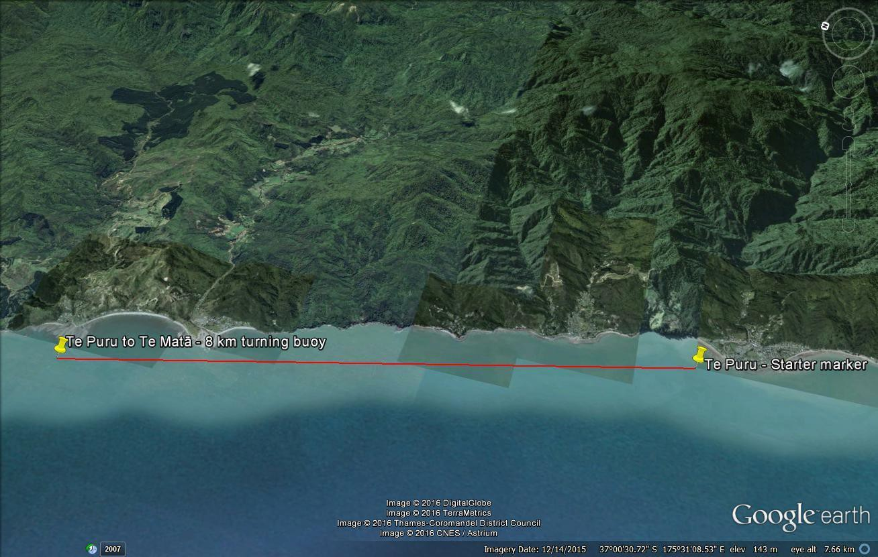  Race Course: 16km  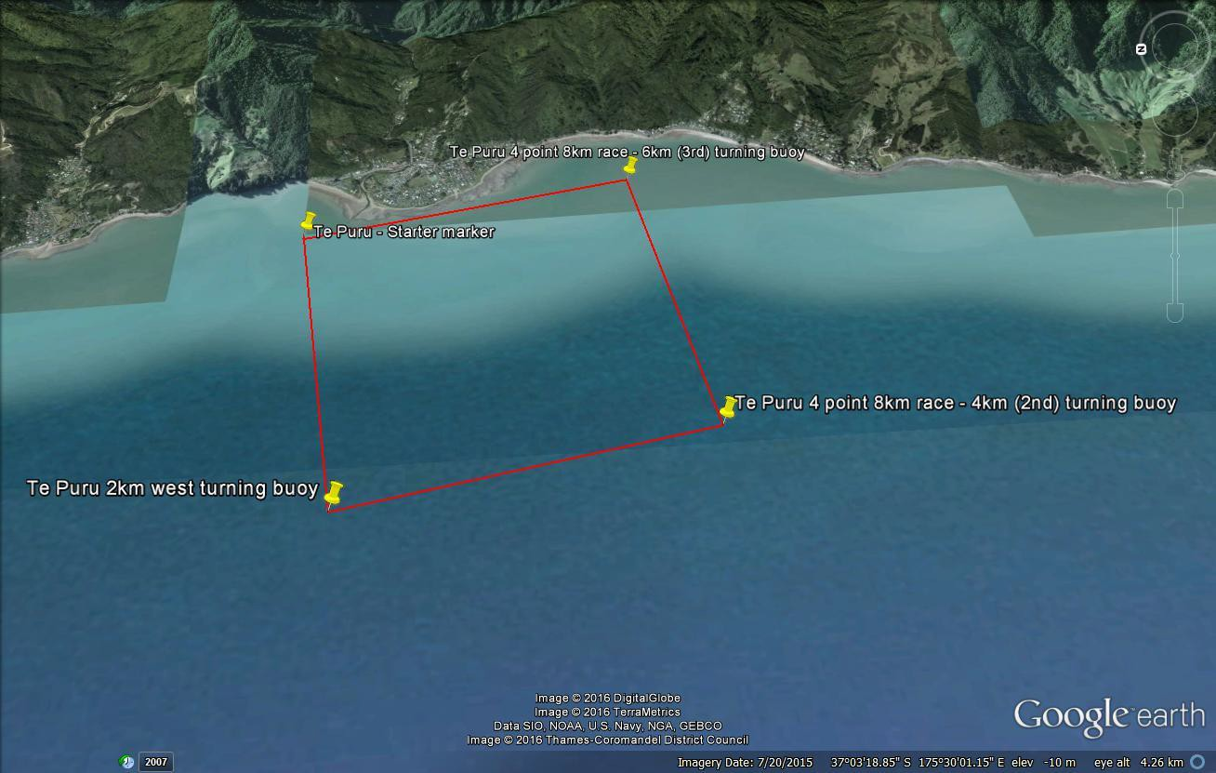  Race Course: 8km  Tides: 7:16am Low Tide | 1:36pm High Tide | Back up course:  The course can be altered to suit conditions should weather be rough. There are 2 alternative courses for each race.  Back up Race course:  Cancellation:  Novice/Junior Race will be cancelled if winds are above 25knots  Mens and Womens W6 16km Race will be cancelled in gale force conditions or where wind speed reaches over 30 knots.

  - Race Day Info

Race Cancellation: Novice/Junior & W1 8km - Race 1 will be cancelled if winds are above 25 knots (46km+).
Senior W6 16km - Race 2 will be cancelled in gale force conditions where wind speed reaches over 34 knots (62km+).This will be at the discretion of the race director.
Food: Kai will be available after each race. Bring with you plenty of hydration as drinking water will be limited.
Parking: Please follow the event signs and instructions of the parking marshalls as we will have designated parking for cars and trailers of W6, Vehicles with W1 and supporting whānau.
Recycling & Waste Management: Recycling and waste bins will be available for use, however we would like to encourage and work towards being a sustainable and waste-free event. Please be mindful about taking your waste away with you and bring along your own cups and/or containers for food and drinks if you can.
Find us on Facebook: Head over to ‘Hauraki Summer Series’ facebook page, give it a LIKE and be sure to change your notifications to receive alerts to keep up to date with the most recent race updates and race day information.
First Aid: Should you require first aid at any time, please report to the admin tent for assistance.
Senior W6 16km -
  - COVID 19 NOTICES

- The event will be held in COVID-19 Alert Level 1
- The event will be postponed/cancelled should we move into COVID-19 Alert Level 2, 3 or 4.
- It is compulsory for all race entries to be processed through the Waka Ama NZ online entry system. This will assist with contact tracing. It is a requirement for all sanctioned events/races under Waka Ama NZ.
- It is compulsory for participants/paddlers to be entered on the online entry system. Failure to do so will mean your race entry is withdrawn. This is a requirement for all sanctioned events/races under Waka Ama NZ.
- A QR code and contact tracing register will be available for participants/paddlers and whānau. This will be located at the admin tent.
- Hand sanitiser will be available for use at the admin tent.
- If you are feeling unwell, please stay home to be mindful of our waka whānau health and wellbeing.

